**Helm for Kubernetes**

1. **Installation**

<https://helm.sh/docs/intro/install/>

winget install Helm.Helm

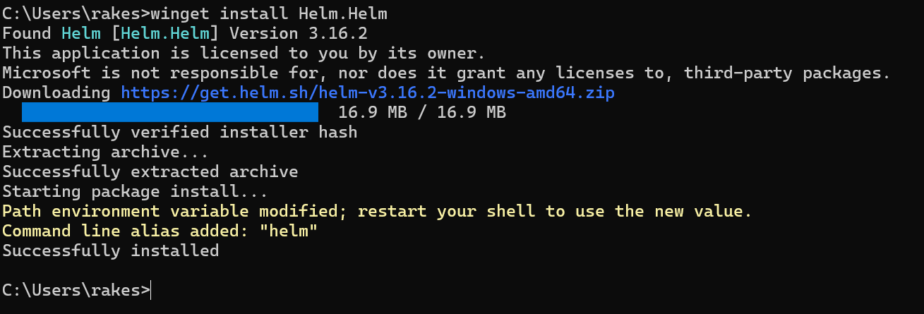

Check version

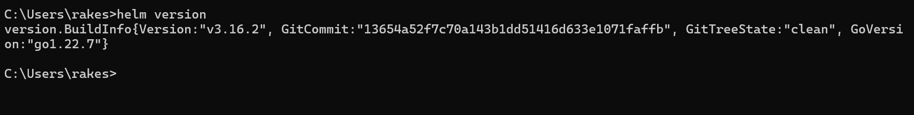

1. **Create a spring boot web application with “Dockerfile.yaml”**

Dockerfile.yaml

|  |
| --- |
| # Use the official OpenJDK 17 image from Docker Hub FROM openjdk:17 # Set working directory inside the container WORKDIR /app # Copy the compiled Java application JAR file into the container COPY ./target/spring-docker.jar /app # Expose the port the Spring Boot application will run on EXPOSE 8080 # Command to run the application CMD ["java", "-jar", "spring-docker.jar"] |

1. **Start docker and minikube**

~ docker context use default

~minikube start --driver=docker

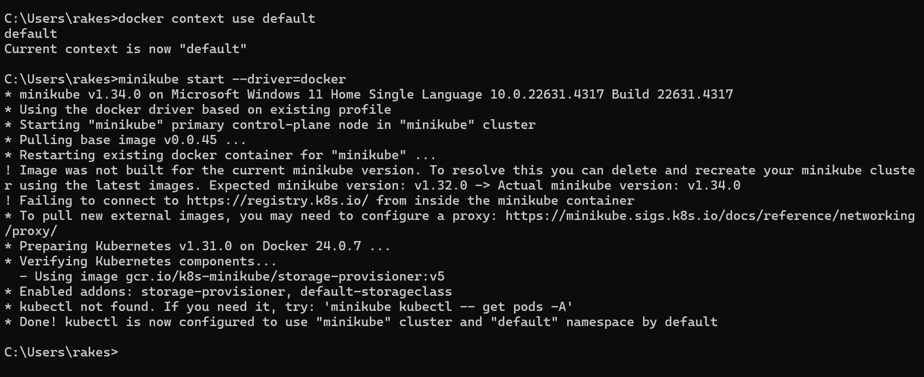

1. **Create Kubernetes images**

minikube docker-env

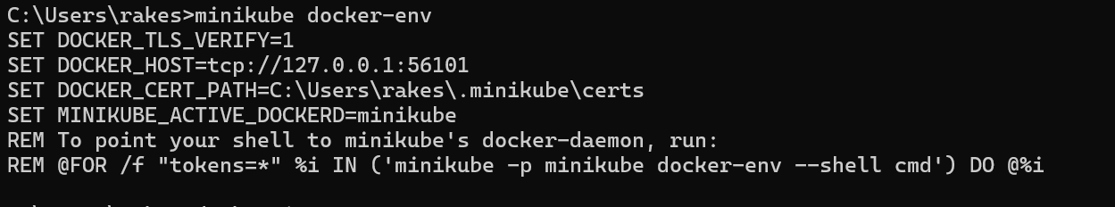

@FOR /f "tokens=*" %i IN ('minikube docker-env') DO @%i



docker images

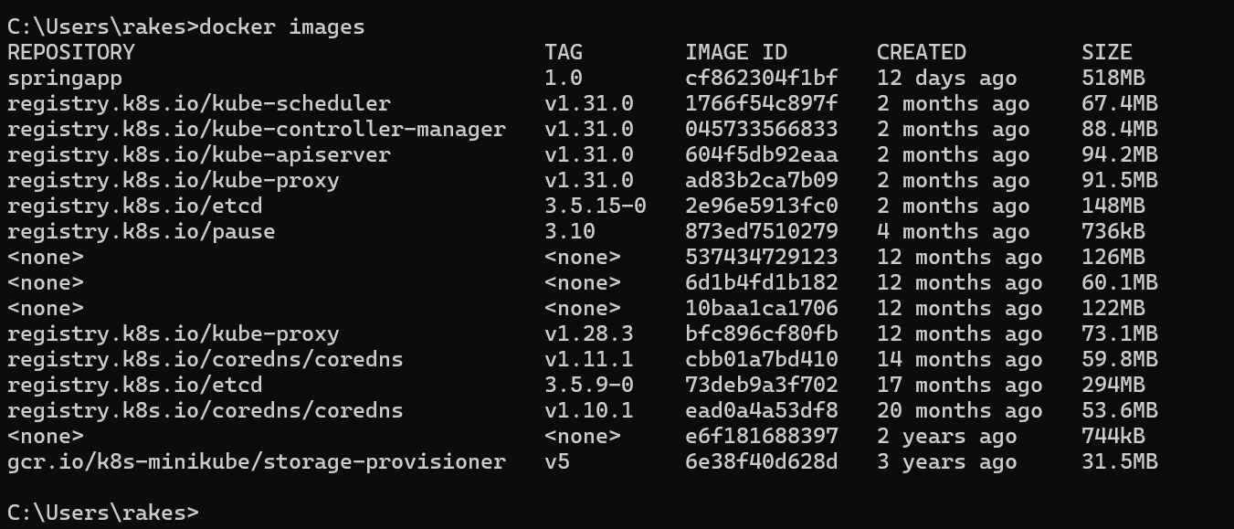

1. **Run spring Application in K8S**

* Build docker image

Goto project directory

cmd: docker build -t spring-helm:1.0 .

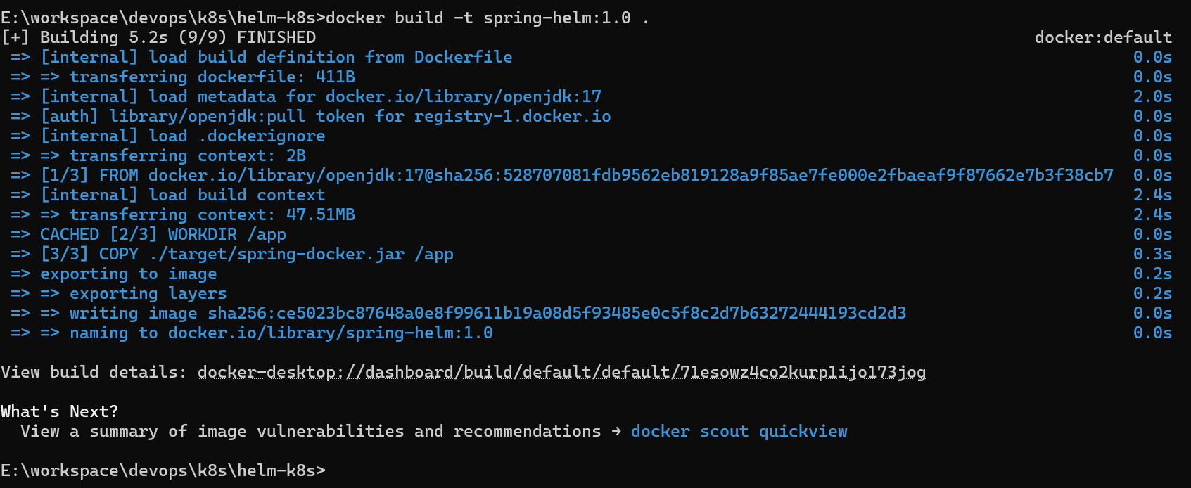

In docker container image is created

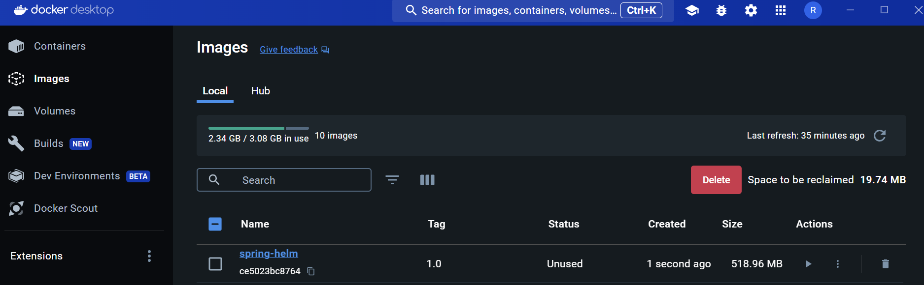

cmd: docker images

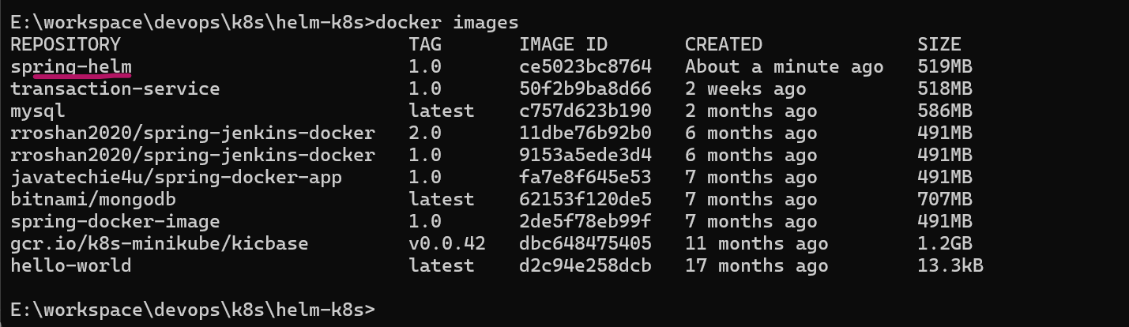

1. **Create helm chart**

cmd: helm create spring-helm-chart

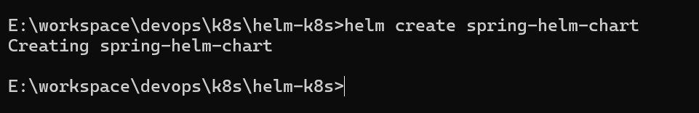

in application can see helm chart created

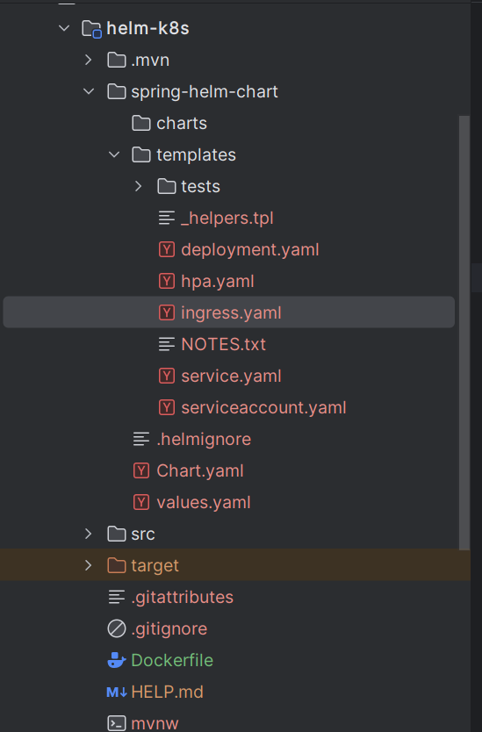

cmd: tree spring-helm-chart

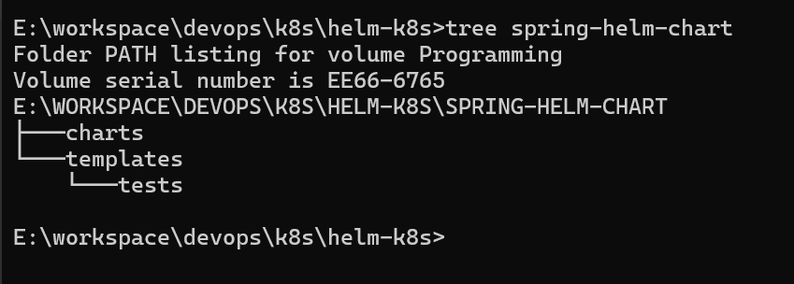

1. **install helm chart**

cmd: helm install myapp-chart spring-helm-chart

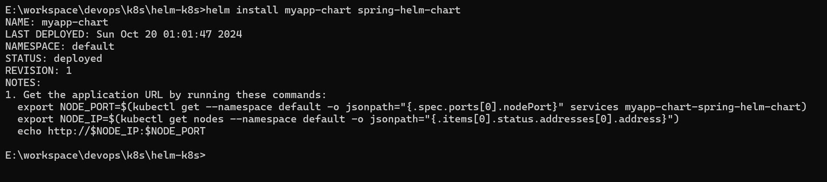

cmd: helm list

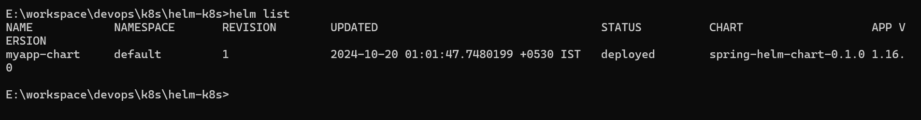

cmd: kubectl get all

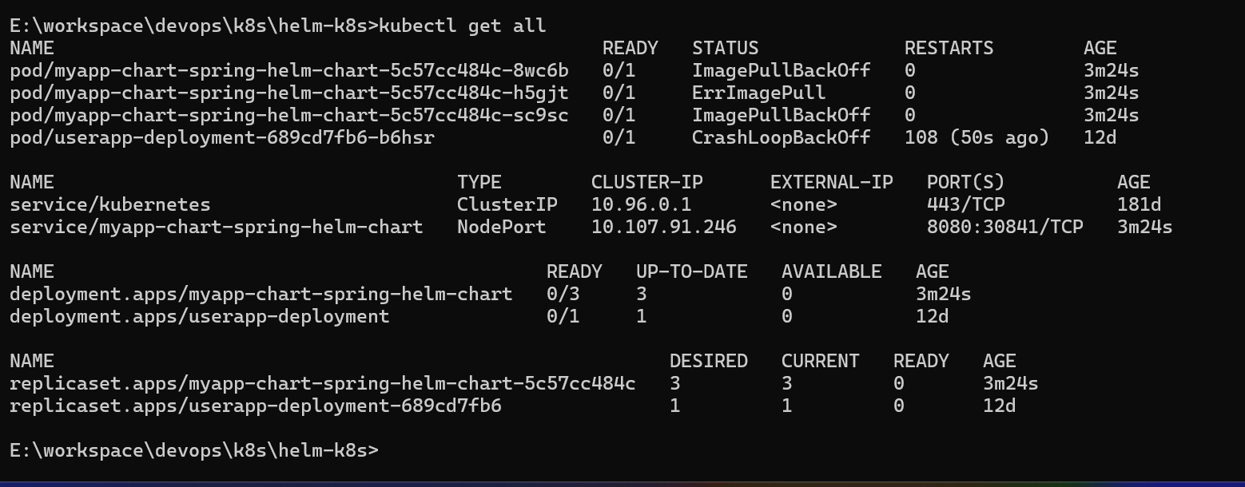

cmd: kubectl get pods

